OCI Document AI Scanner

The application opens up the functions of the Oracle Cloud - Document Understanding AI Service in a modern APEX user interface. The aim of the application is to process several pdf or image files in one job and to provide the results of the analysis (text extraction, table extraction, document classification, key value extraction) as a ZIP file for download or export to an accounting database. The details can be displayed and improved on the Processor job details and Document analysis pages.
Inhaltverzeichnis
Sign up on the login page 3
User interface language 3
UI Appearance 4
Create processor orders 5
Process documents 6
Download results 6
Evaluate results 6
Order delete 7
Processor job details 8
Export invoices 9
Document analysis 10
document attributes 11
field labels 12
line item 14
invoice items 15
Tables 16
Lines of text 17
Text preview 17
Search documents 18
Configuration 19
AI processor configuration 19
Configuration - Field Types 23
Configuration - Line Item Types 24
Configuration - Languages 25
Configuration - Text Index Status 26
Installation 26
Requirements 26
OCI configuration 27
Install APEX application 29
Processing of processor orders 30
1. Store files in the object store 30
2. Compile and start the processor job 30
3. Awaiting processing 30
4. Processing of the results 30
5. Algorithm for Analyzing Text Fragments 31

Sign up on the login page
The application requires the username and password of the APEX account set up by the administrator of the APEX workspace.
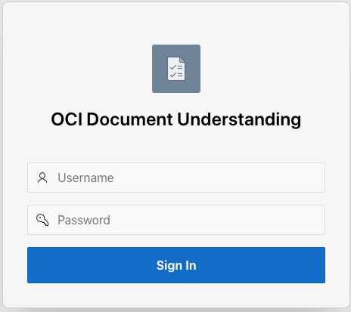

User interface language
After logging in, the user interface language can be changed. To do this, click on the user icon with their name in the top right corner and select Language. A list of languages appears in the top left. Select the appropriate language by clicking on an entry. The languages German, English, French, Italian and Dutch are currently supported.
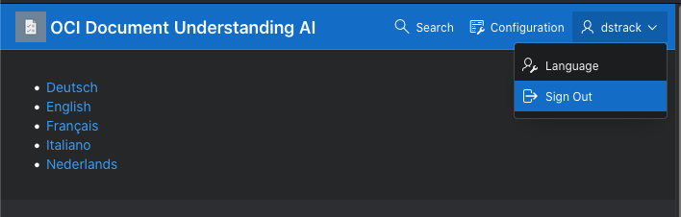

UI Appearance
Click Customize on the bottom left and a dialog box titled Appearance will appear. You can personalize the appearance of this application by changing the theme style.
Choose a theme style from the list below and click Apply Changes.

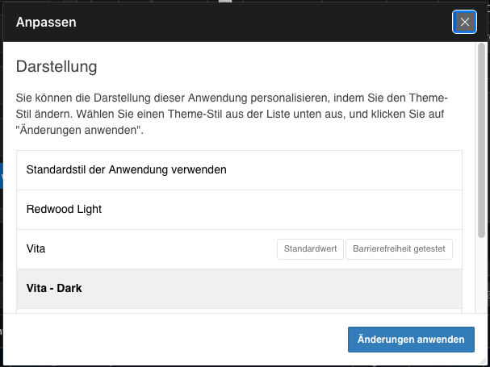

Create processor jobs
New orders can be created and completed orders can be viewed on the home page. For a new job, load multiple files by dragging and dropping them into the designated zone at the top left of the page. Set the document type, language and context of the documents.
For the import of invoices, set the document type to Invoice, language to English, and the context to the appropriate project name.
With the language setting English, it is ensured that American formatted numbers and date values can be converted, even if they occur in German documents.
With the document type setting Invoice, it is ensured that the appropriate field names are searched for, even if a different document type was determined by the document analysis.
Only single invoices per PDF file
The scans of the invoices should contain only a single invoice. The program CANNOT recognize and break down multiple invoices in one PDF document! On a Mac, with the Preview program, a new document per page can be created by drag and drop of a page onto the desktop, if necessary.

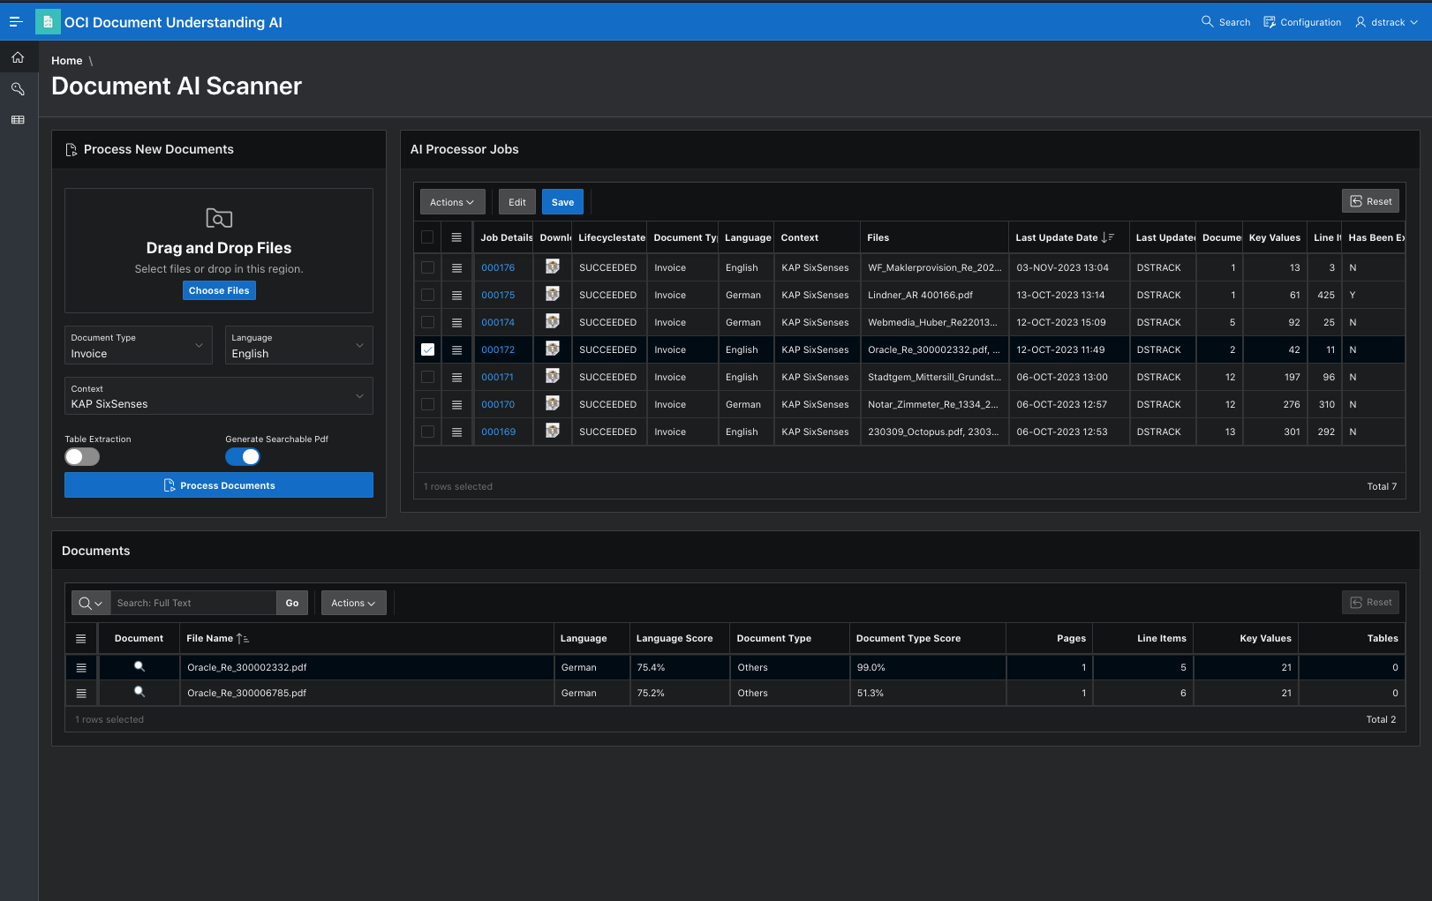

Document type
Select the type of documents uploaded. The document type determines which type of field content and line item is generated in the report.
Language
Select the language of the uploaded documents. The language determines which country- specific data formats are used when converting to numbers and dates.
Context
Select the context for the uploaded documents. In the case that the results after the analysis e.g. are to be assigned to a project, you can set the project here.
Table extraction
Activate this option if you want to evaluate the tables contained in the documents. Table extraction can only be used with some document types.
Create searchable PDF
Activate this option if you want to convert the uploaded documents into searchable PDF. This makes these documents searchable with an Oracle Text Index.

Process documents
Start the job by clicking on 'Process documents'. A dialog window informs about the progress and the completed percentage of the job during execution.

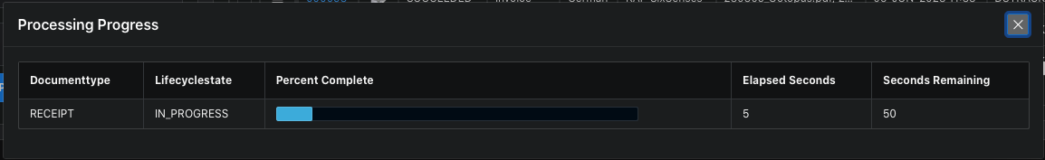
When the job is complete, the dialog box will disappear and the processor job details will be displayed.

Download results
Click on the ZIP file icon in the Download column of the AI Processor Jobs list to start the download. The zip file contains a directory structure with the various lists of results. The folder has the name Document_AI_Files_X and ends with the job number.
The directories csv_files and searchable_pdf are included.
In csv_files you will find the files that you can evaluate in Numbers or Excel. Depending on the type of order, there are files with the names of the documents and the extensions X_Line_Items.csv and X_Tables.csv. Also Invoices_List_X.csv, Receipts_List_X.csv, Driver_License_List_X.csv, Passport_List_X.csv files with field values for each corresponding document.
The searchable_pdf directory contains the searchable PDF files for the uploaded documents.

Evaluate results
Select an entry in the AI Processor Jobs list by clicking on the desired row. The individual documents for the selected entry are listed in the Documents list. Click on the job number in the Job Details column to view processor job details, or click on the magnifying glass icon in the Document column to view the document analysis results.

Delete Job
After you have downloaded or evaluated the results, the job can be deleted. To do this,
select 'Delete row' from the row menu and then click on Save. With the deletion, the memory used in the database and also in the object store is released again.

Processor job details
This page can be used to view order identification data and a quick view of recognized field labels with content for invoices with invoice line items and receipts with receipt line items. Click on the magnifying glass icon in the Document column to open the document analysis.

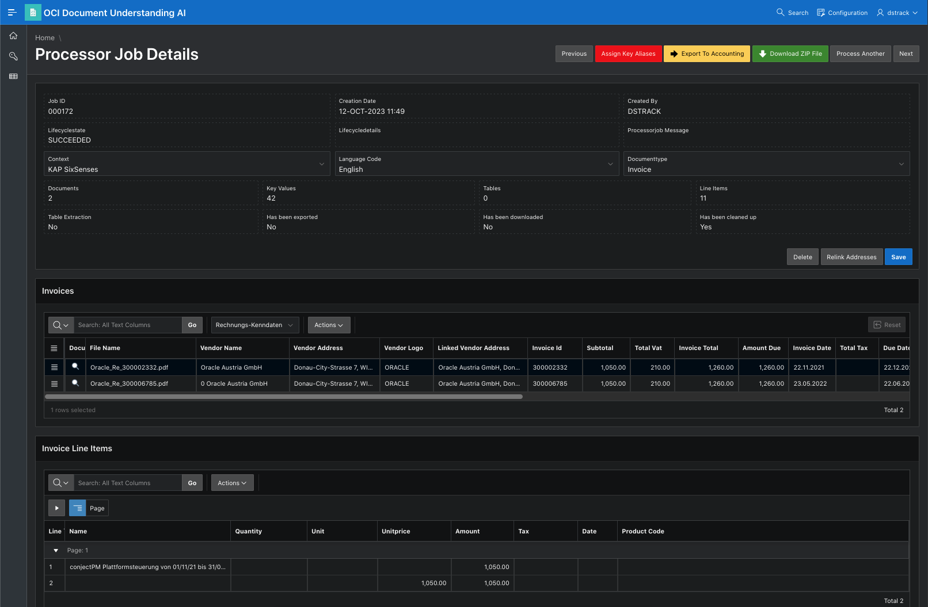

Export invoices
A click on 'Export to Accounting' displays a preview of the exported data. With a click on 'execute export', the displayed data is transferred to the accounting database as incoming invoices. The searchable Pdf files are transferred to the accounting database as attachments to the invoices. After the export, the button is hidden to prevent a double export.

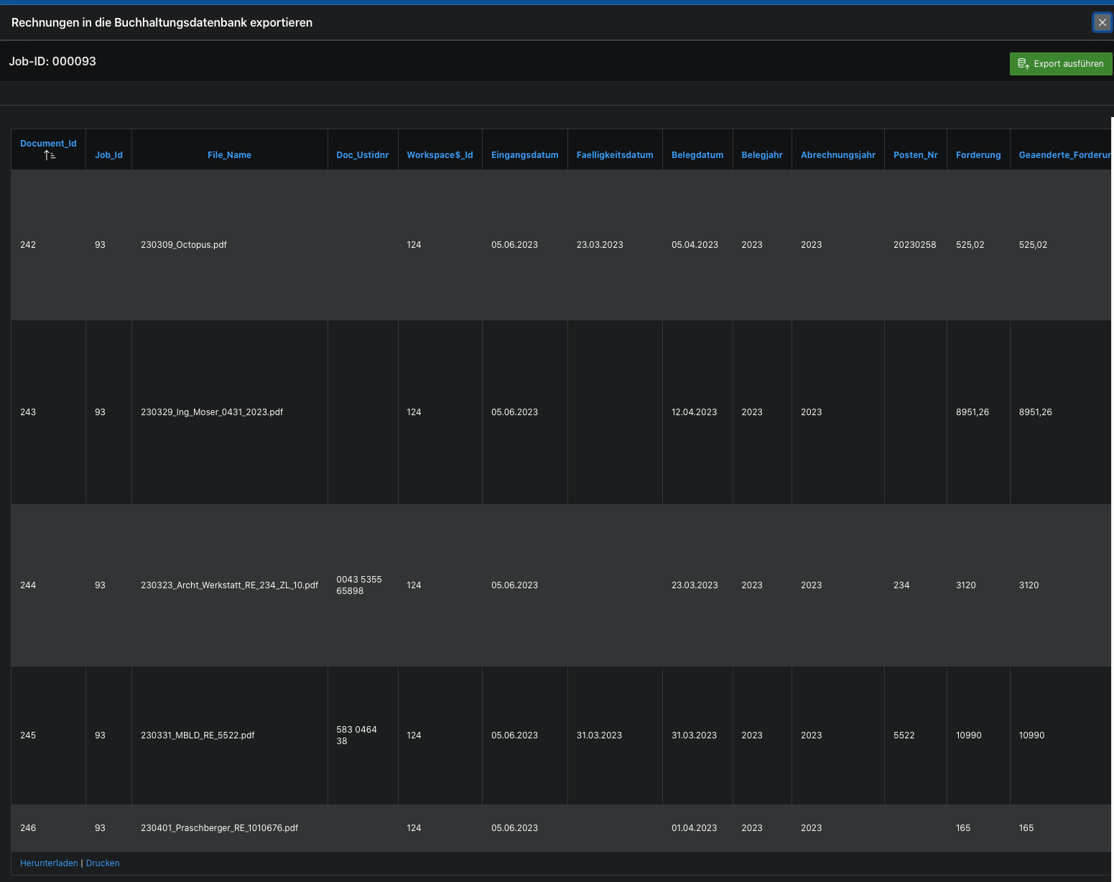

Document analysis
On the Document Results page, the searchable PDF view of the uploaded document is displayed on the left. The document can be downloaded as a PDF file in the lower area of the view.
At the top right you can choose from the possible evaluations. Depending on the recognized document type, document attributes, field labels, line items, invoice items, receipt line items, tables and text lines are displayed here.

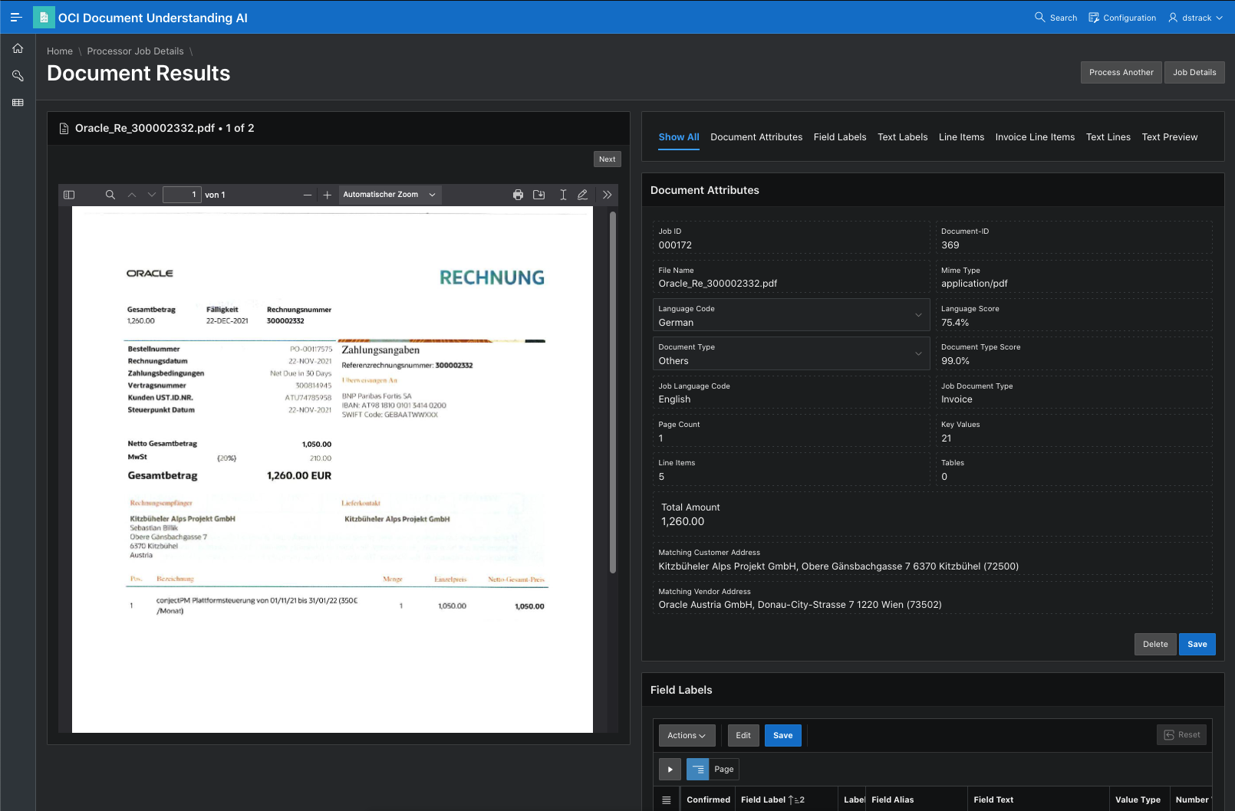

document attributes
In addition to the document identification data (job ID, file name, MIME type), the recognized language and the document type are also displayed here. The language and the document type can be changed if necessary so that the appropriate number and date formats can be used in the evaluation. For invoices and receipts, the number of pages, field values, line items and tables, total amount and associated addresses are displayed.

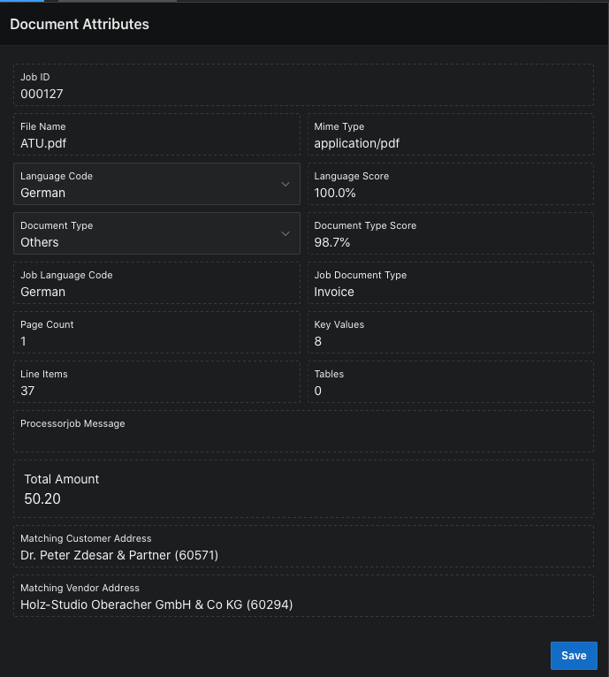

field labels
The field labels found by the processor are listed for the output of the invoice and receipt data. The user can check and improve the data associations found by the processor.
1. Several options
If fields occur more than once, the user can select the desired entry by clicking in the 'Confirmed' column.
2. Data Conversion
In the Numerical Value and Date Value columns, the field text or field value is output as a converted number or date. If the data is not converting as expected, the language for a document can be set to apply the appropriate format masks and currency symbols. Several variants can be used for each language. For example, if the language German was
selected for the processor job and the processor finds the language English for a document, then 4 variants are used for the recognition and conversion.
Language | Territory | Date format | Number format | Currency Symbol | Currency Code
English | AMERICA | MM/DD/RRRR | 999,999,999.99 | $ | USD
English | UNITED KINGDOM | DD-MON-RRRR | 999,999,999.99 | £ | GBP
German | GERMAN | DD.MM.RRRR | 999.999.999,99 | € | EUR
German | AUSTRIA | DD.MM.RRRR | 999 999 999.99 | € | EUR

3. Field Labels mapping
The field name can be reassigned in the User Label column.
If there are several options for a field, the desired entry can be selected by clicking in the Confirmed column.
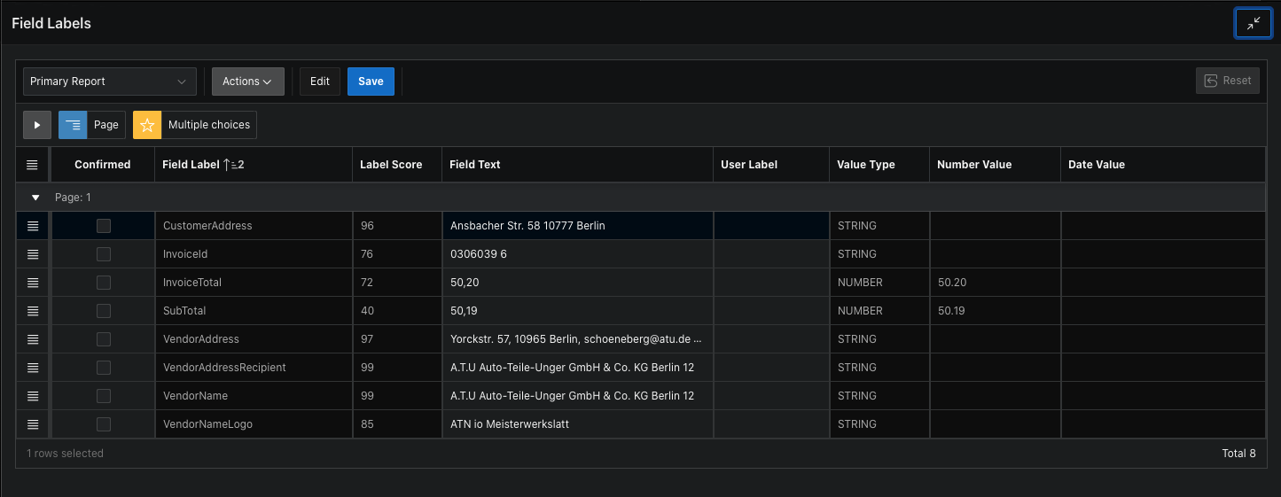

line item
The individual items found by the processor are listed for the recognized document types invoice and receipt. If the user recognizes invoice fields in the list, a suitable entry can be selected with a click in the column User field designation. These fields are then listed as entries in the Field Labels list.
For example, the invoice amount can then be marked if the processor was unable to do so.
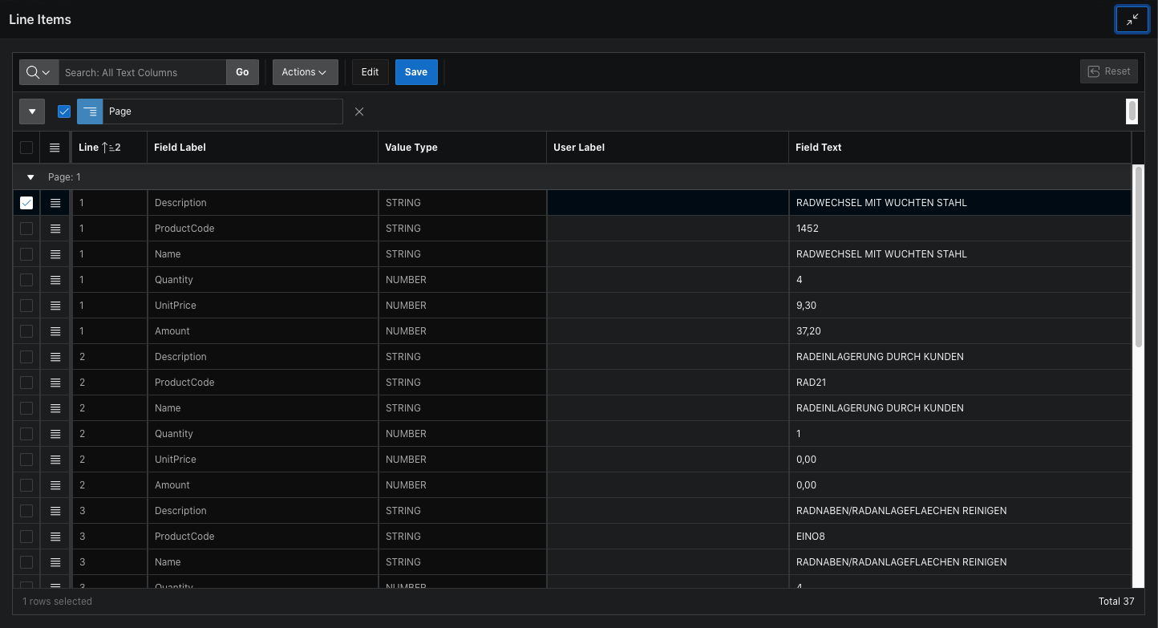

invoice items
For the invoice document type, the list of invoice items is formed from the individual items.
Recognized and converted numbers and date fields are formatted uniformly.
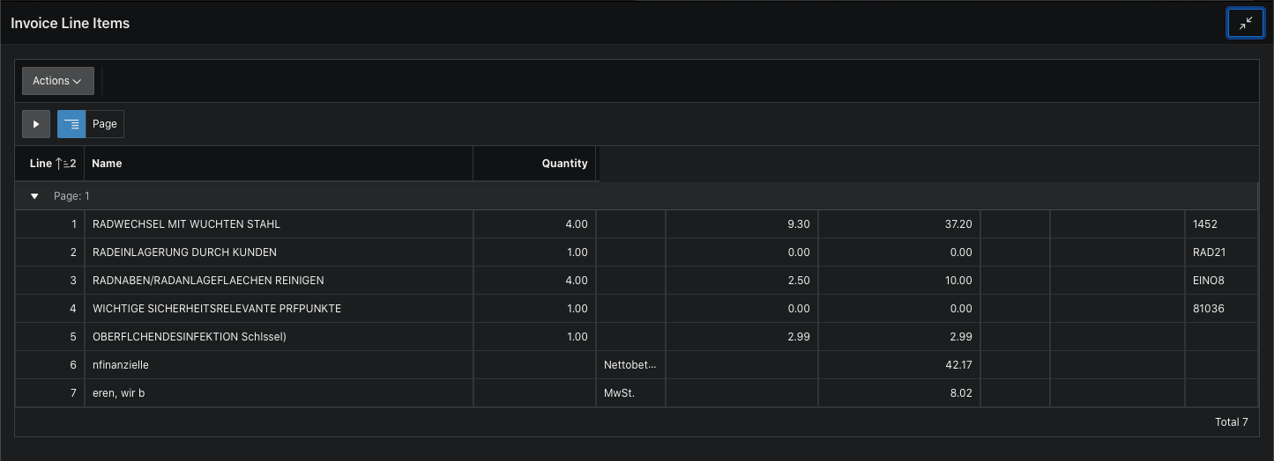

Tables
The tables recognized by the processor in the documents are listed here.
The first row of a table is highlighted in the report view. In the popup field 'Table' a table can be selected from a list of all tables in the document.
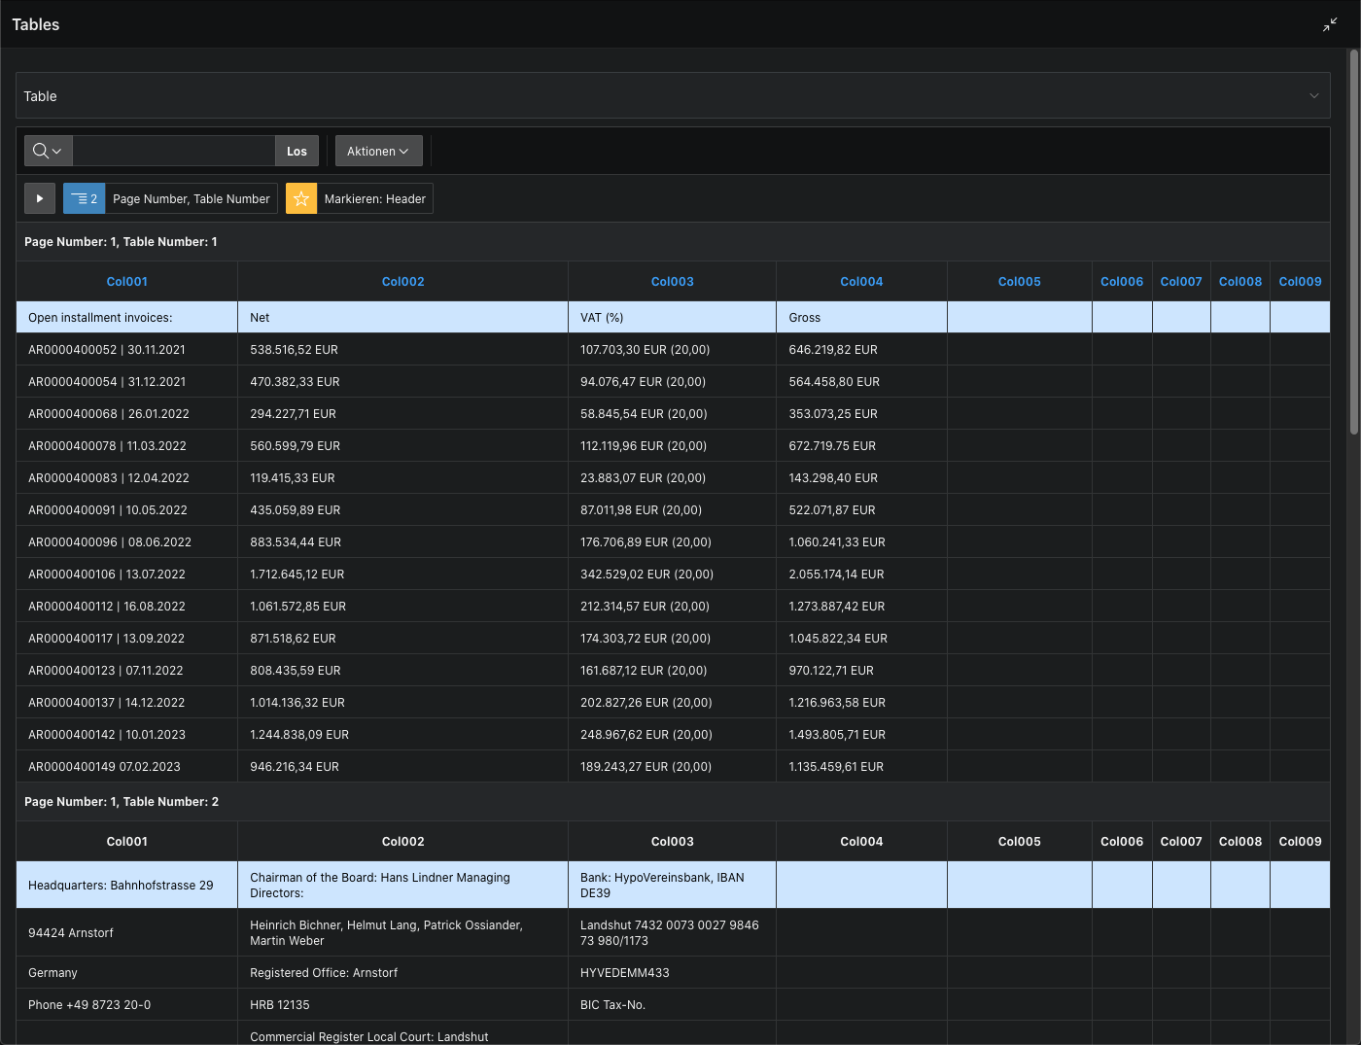

Lines of text
The text lines recognized by the processor in the documents are listed here.
If a line of text is recognized as a date or number according to the formats of the document language, then the corresponding entries are displayed in the Value Type, Number Value and Date Value columns.
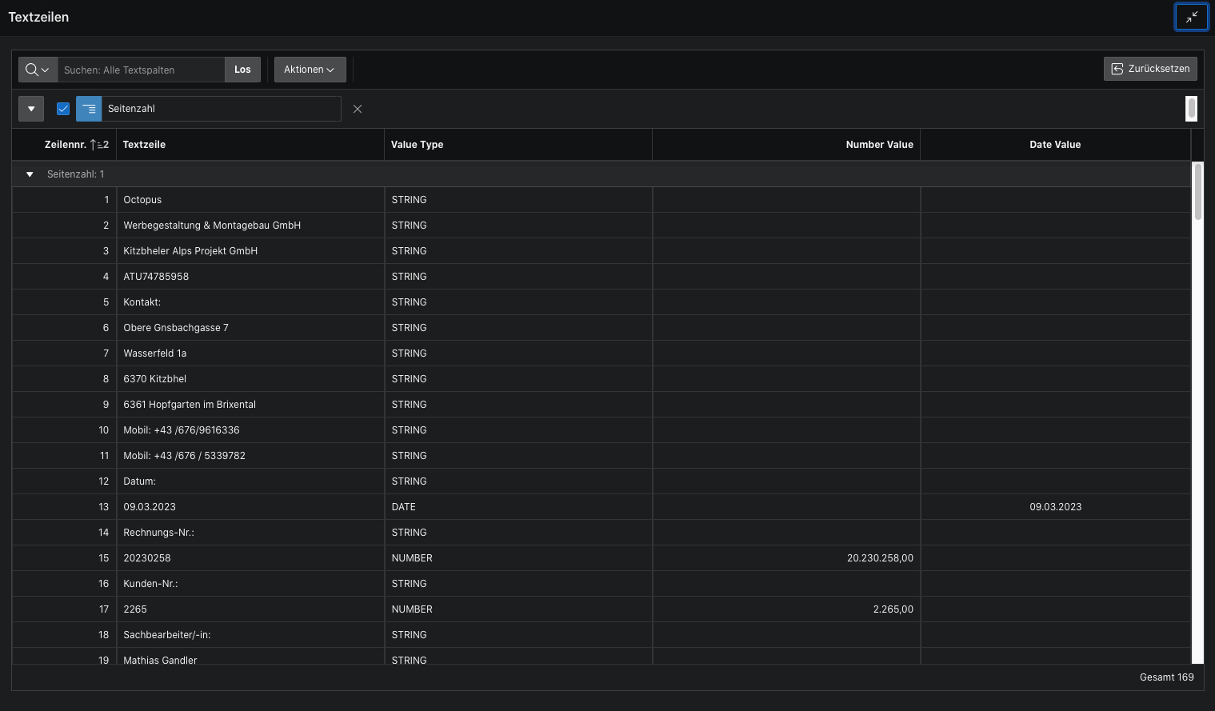

Text preview
The entire text as used in the text index is output here.
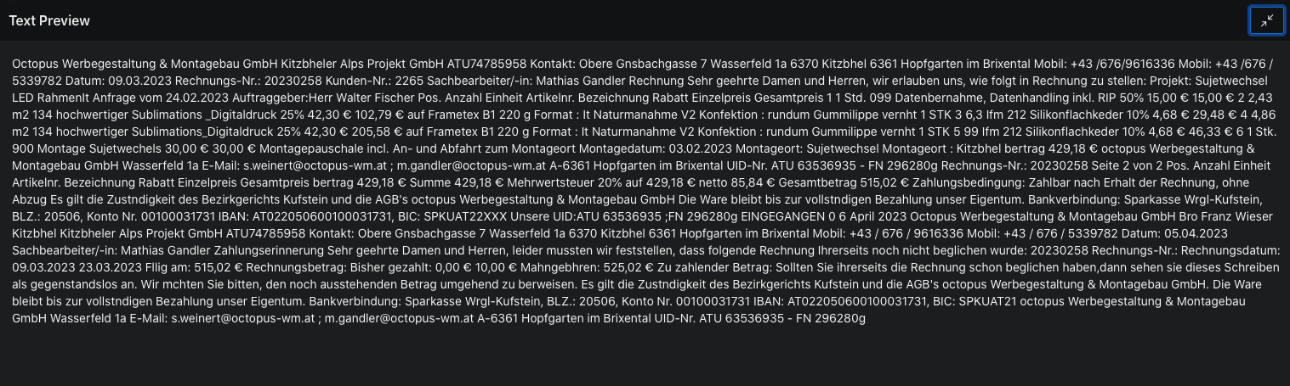

Search documents
Clicking on the magnifying glass icon in the top right corner of the menu bar opens a dialog window for the full-text search. The searchable Pdf files stored in the object store can be quickly searched with an Oracle text index. By entering keywords, corresponding documents are listed. With a click in the list of search results, the document can be opened in the Document Analysis page.

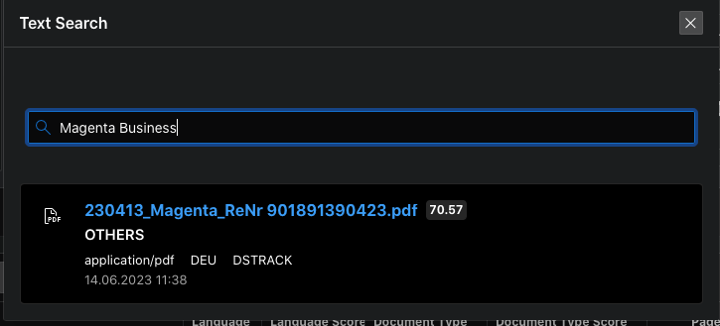

Configuration
Clicking on the Configuration entry in the menu bar at the top right opens the dialog window for the AI processor configuration. In addition, the field types, line item types and languages are set up here as defined for the processor version in the manufacturer specifications and your Oracle Cloud console.

AI processor configuration
All necessary parameters for accessing the Oracle Object Store and the AI Document Understanding web service are set up here.
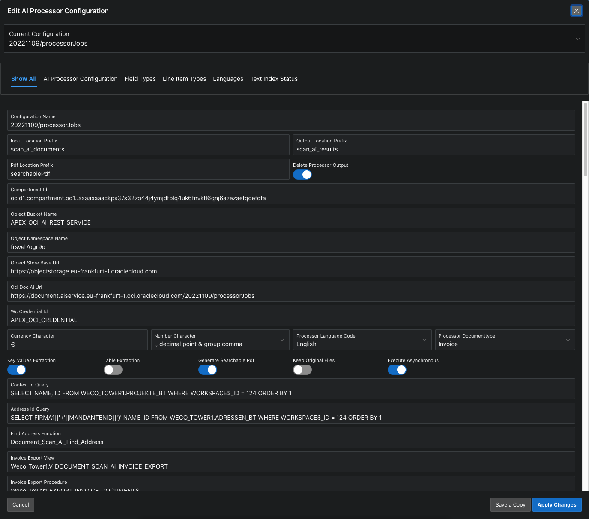

Field-Name | Column-Name | Example Contents | Meaning
Configuration name |  | 20221109/processorJobs | Name of the configuration
Input location prefix | input_location_prefix | scan_ai_documents | Collection folder name for the uploaded files in the object storage
Output location prefix | output_location_prefix | scan_ai_results | Collection folder name for the AI processor results in the object storage
PDF location prefix | pdf_location_prefix | searchable_pdf | Collection folder name for searchable pdf documents in the PDF location prefix in the object storage
Compartment ID | compartment_id | ocid1.compartment.oc1..aaaaaaaa... | Compartment_Id in the object storage
Object bucket name | object_bucket_name | APEX_OCI_AI_REST_SERVICE | Bucket name in the object storage
Object namespace name | object_namespace_name | frsvel7xgy9o | Object namespacename in object storage
Object storage base URL | object_store_base_url | https://objectstorage.eu-frankfurt-1.oraclecloud.com | Base_Url of the object store
OCI Doc AI Url | oci_doc_ai_url | https://document.aiservice.eu-frankfurt-1.oci.oraclecloud.com/20221109/processorJobs | Base_Url of the Document Understanding AI Processor
WC Credential ID | wc_credential_id | APEX_OCI_CREDENTIAL | Static name of the web credentials in the APEX workspace
Context ID Query | context_id_query | select name d, id r from projects | Value list - select statement for the assignment of a context for later processing
search function | find_address_function | Document_Scan_AI_Find_Address | Function name for the address search
Address list query | address_id_query | Select name, id from addresses | Value List - select statement for the display of addresses
Invoice export view | invoice_export_view | Weco_Tower1.V_DOCUMENT_SCAN_AI_INVOICE_EXPORT | Name of the SQL view for Invoice export
Invoice export procedure | invoice_export_procedure | Weco_Tower1.EXPORT_INVOICE_DOCUMENTS | Name of SQL procedure for invoice export
currency sign | currency_character | € | Währungszeichen Standardvorgabe
number character | number_character | ,. | Default Decimal & group character
Processor language code | processor_language_code | English | Processor Languages Default. Must be English if key value extraction is enabled.
Processor document type | processor_documentType | Invoice | Document Type Default
key values extraction | Key_Values_Extraction | On | Processor Option Key Value Extraction - Generates  field labels and line items  for invoices, receipts, and field labels for passport, driver's license
table extraction | Table_Extraction | On | Option Table Extraction - Generates tables with information about the page, number of columns and rows from the document contents.
Generate searchable PDF | generate_Searchable_Pdf | On | OCI Processor Option Generate Searchable PDF - generate searchable PDF from document content. The files are generated in the object store with the PDF location prefix. An Oracle Text Index makes the documents searchable with keywords.
Delete processor output | delete_processor_output | On | delete AI Processor results in object store after storing data in SQL table.
Keep original files | keep_original_files | Off | do not delete the uploaded files in the object store. when Generate Searchable PDF is turned on, the files can be searched even if the original files have been deleted.
Run asynchronously | execute_asynchronous | On | f is switched on during the execution of OCI Processor jobs, a dialog window with the processing progress and a forecast of the processing time in seconds  is displayed. Also, this avoids a timeout error due to too long processing time.

Set up Oracle Text Index for the address table
In order to make the table with the field contents from the analysis result searchable, an Oracle Text Index must be set up for the address table. You can find an example of this in the
Accounting_Address_Text_Index.sql file.
Register the address lookup function
A function with the profile
FUNCTION Find_Address (p_Search IN VARCHAR2,p_Language IN VARCHAR2) RETURN NUMBER is installed in the application scheme and entered in the configuration (find_address_function). See the Accounting_Find_Address.sql file for an example.
Set up queries for context and addresses
Select queries for the address list (address_id_query) and project list (context_id_query) are entered.
Example for address_id_query: SELECT COMPANY1||' ('||TENANTID||')' NAME, ID FROM WECO_TOWER1.ADRESSEN_BT WHERE WORKSPACE$_ID = 124 ORDER BY 1
Example of context_id_query: SELECT NAME, ID FROM WECO_TOWER1.PROJEKTE_BT WHERE WORKSPACE$_ID = 124 ORDER BY 1
Set up export to accounting
In the Invoice export view field, the name of the SQL view for the export view and in Invoice export procedures the name of the SQL procedure for the invoice export to accounting is set up. The export view shows the data compilation resulting from the context (project), the invoice data and the addresses found. For a job ID, the procedure transfers the data from the export view to the accounting database as incoming invoices with attachments. You can find an example of this in the Accounting_Invoice_Export.sql file.
Manage multiple configurations
The current configuration can be created as a duplicate by clicking on 'Save a copy'.
Rename by changing the content of the Label field.
Custom settings for processor configuration, field types, line item types and languages can be made in the duplicate.
If you have multiple configurations, you can select one from the list at the top of the page and mark it as the current configuration.

Configuration - Field Types
All field names of the key value extraction for the individual document types are defined here. Their meaning, value type, and format masks as defined for the processor version in the manufacturer specification are set up here. For the assignment of the field types to a document, the document type of the order and the document type determined for each document are taken into account and valid field types are adopted in the results output.

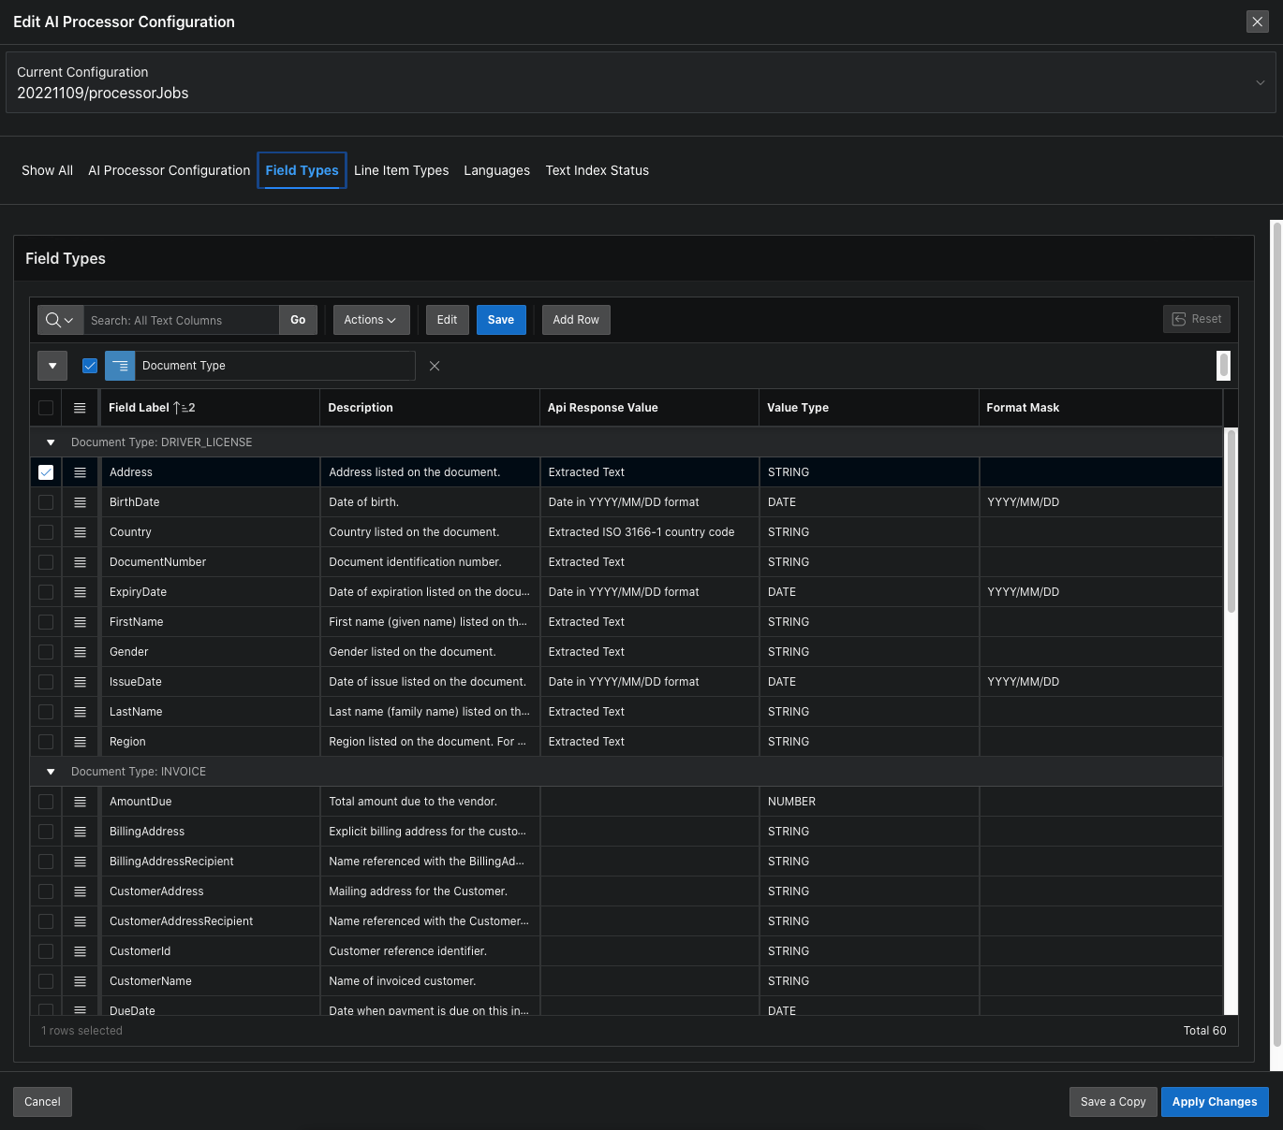

Configuration - Line Item Types
All field names of the line item extraction for the document types invoice and receipt are defined here. Its meaning and value type as defined for the processor version in the manufacturer specification are set up here.

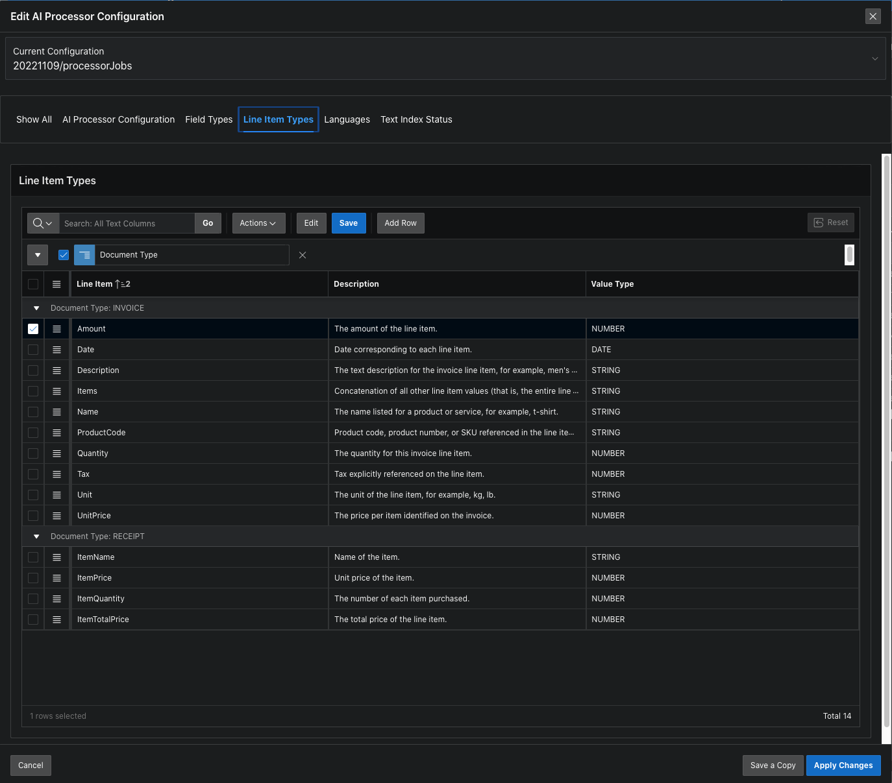

Configuration - Languages
The list of languages includes NLS parameters with which the texts in the processor output are converted to Oracle Number and Date data types if the data matches the parameters. Several lines can be defined for each ISO code. In order to convert the correct data from the field contents of the number and date type, the language of the order and the language determined for each document are used to determine the conversion parameters. If, for example, the language of the order is German and the determined language of a document is English, then the lines with the areas AMERICA, UNITED KINGDOM and GERMANY are considered for the conversion and valid conversions are included in the output results.

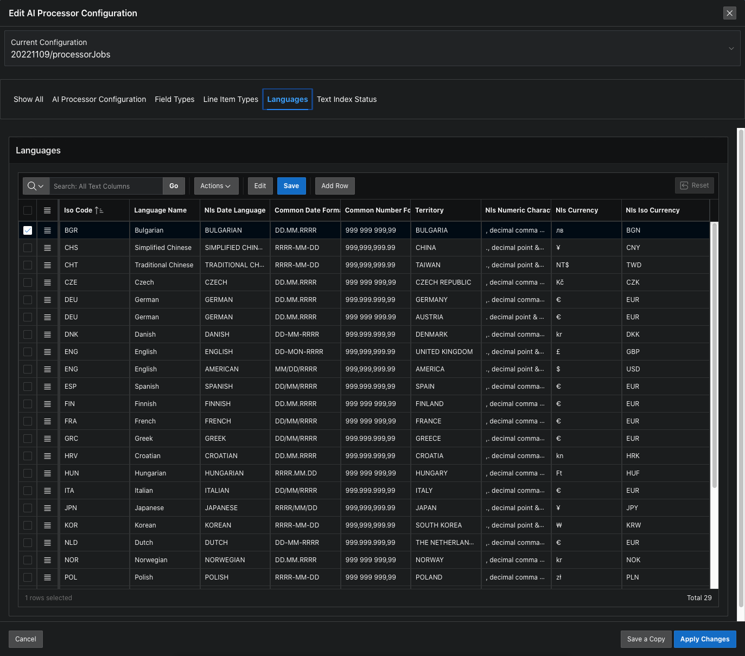

Configuration - Text Index Status
The status of the text index is listed here for all documents. With a click on 'Rebuild Text Index' the index can be rebuilt if necessary.
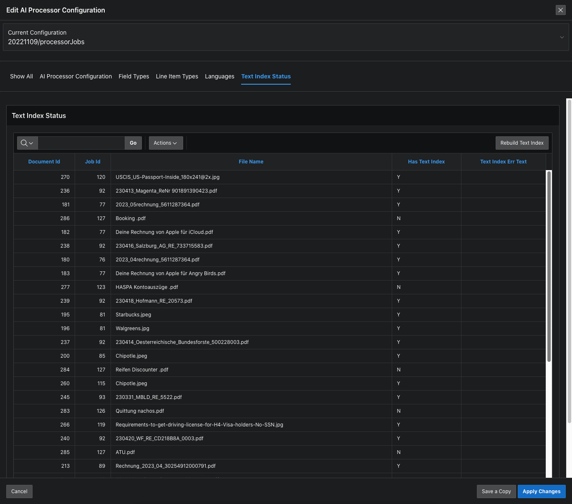

Installation

Requirements
Prerequisites are a paid Oracle Cloud environment with an admin account to set up the required services and permissions.
The following schema permissions are required to install the supporting objects:
As SYS or ADMIN User:
GRANT EXECUTE ON CTXSYS.CTX_DDL TO <APP_SCHEMA>; – for Oracle Text Index
GRANT EXECUTE ON SYS.DBMS_LOCK TO <APP_SCHEMA>; – For Wait in asynchronous execution
GRANT EXECUTE ON DBMS_CLOUD TO <APP_SCHEMA>; – For Object Store access

OCI configuration
Security_Group, IAM User, API keys, Compartments, Policies and Object Storage Bucket must be configured in the OCI Service Console. Web credentials must be configured in APEX.
Example OCI configuration
Identity / Domains / Default domain /
Groups
Name: APEX_OCI_AI_REST_Security_Group
Description: Security Group for access to AI Services
Users
User Type: IAM User
Capabilities:
API keys: Yes
Auth tokens: Yes
Name: APEX_OCI_AI_REST_Service_Account
Description: Application User for AI REST Services
Email: your.name@example.de
Groups: APEX_OCI_AI_REST_Security_Group

API keys:
Download Private Key, Download Public Key
Configuation file - Copy
[DEFAULT]
user=ocid1.user.oc1..aaaa...
fingerprint=66:40:...
tenancy=ocid1.tenancy.oc1..aaaa...
region=eu-frankfurt-1
key_file=<path to your private keyfile> # TODO

Auth tokens:
Description : Access Buckets – Authentication token for DBMS_CLOUD.CREATE_CREDENTIAL
Generate Token - Copy:
;...-b<FvGe

username => 'APEX_OCI_AI_REST_Service_Account'
password => ';...-b<FvGe'

Identity / Compartments
Name : APEX_OCI_SERVICES
Description: Compartment for Secure APEX Access to OCI Object Storage and AI REST Service
OCID <Copy> : ocid1.tenancy.oc1..aaa...

Identity / Policies
Name: APEX_OCI_AI_REST_Bucket_Policy
Description: Policy to assign APEX Access to OCI Services
Compartment: strackdev (root)/APEX_OCI_SERVICES
Policy Builder - Show manual editor:
Statements:
allow group APEX_OCI_AI_REST_Security_Group to read buckets in compartment APEX_OCI_SERVICES
allow group APEX_OCI_AI_REST_Security_Group to manage objects in compartment APEX_OCI_SERVICES where all {target.bucket.name='APEX_OCI_AI_REST_SERVICE', any {request.permission='OBJECT_CREATE', request.permission='OBJECT_INSPECT', request.permission='OBJECT_READ',request.permission='OBJECT_OVERWRITE'}}
allow group APEX_OCI_AI_REST_Security_Group to manage object-family in compartment APEX_OCI_SERVICES
allow group APEX_OCI_AI_REST_Security_Group to manage ai-service-document-family in compartment APEX_OCI_SERVICES

Object Storage
Compartment: APEX_OCI_SERVICES
Buckets: APEX_OCI_AI_REST_SERVICE
Default Storage Tier: Standard
Visibility: Private
Namespace <Copy>: frmnolrlgf8w

APEX Builder / Workspace Utilities / Web Credentials
Name: APEX OCI Credential
Credential Static ID: APEX_OCI_CREDENTIAL
Authentication Type: Oracle Cloud Infrastructure (OCI)
OCI User ID <API Keys Configuation file user>: ocid1.user.oc1..aaa...
OCI Private Key <API Keys private key file CR removed>: MIIEvQIBAD…
OCI Tenancy ID <API Keys Configuation file tenancy>: ocid1.tenancy.oc1..aaaa...
OCI Public Key Fingerprint <API Keys Configuation file fingerprint>: 5e:7b:...

Document Understanding API
Lookup your URL: https://docs.oracle.com/en-us/iaas/api/#/en/document-understanding/20221109/
API Endpoint: https://document.aiservice.eu-frankfurt-1.oci.oraclecloud.com/20221109

Install APEX application
Import the Oracle APEX installation file OCI_Document_Understanding_App.sql
Install the application and the supporting objects.

After installation as APP_SCHEMA user:
GRANT SELECT ON V_DOCUMENT_SCAN_AI_INVOICES TO <ACCOUNTING_SCHEMA> WITH GRANT OPTION;
GRANT SELECT ON V_DOCUMENT_SCAN_AI_LINE_ITEM_INVOICE TO <ACCOUNTING_SCHEMA> WITH GRANT OPTION;
GRANT SELECT ON V_DOCUMENT_SCAN_AI_DOC_FILES TO <ACCOUNTING_SCHEMA> WITH GRANT OPTION;
After installation as ACCOUNTING_SCHEMA user:
GRANT SELECT ON V_DOCUMENT_SCAN_AI_INVOICE_EXPORT TO <APP_SCHEMA>;
GRANT EXECUTE ON Export_Invoice_Documents TO <APP_SCHEMA>;

Processing of processor orders

1. Store files in the object store
The files uploaded in the job are stored in a subdirectory with a job number according to the configuration bucket name and input location prefix (input_location_prefix). The original file names are used after a conversion of special, accent and space characters. The conversion is necessary because the permitted character set is restricted.

2. Compile and start the processor job
The list of uploaded file locations and the specifications like document type, language and recognition features like text extraction, table extraction, document classification, key value extraction are sent to the processor as a job.

3. Awaiting processing
If the configuration Run asynchronously is activated, a scheduler job is started that updates the
processor job status. The processor job status is called up in the user interface every 2 seconds and a dialog window informs about the status and the completed percentage of the job during execution. When the job is done, processing continues.

4. Processing of the results
After the successful completion of a processor job, the recognized language and document type, field labels with field contents, line items and tables are extracted from the analysis result of the processor job. Numbers and dates are converted according to country-specific formats because the AI processor only knows American formats.
The country-specific date formats, currency symbols, currency code, and decimal and group sign of the languages of the processor order and the found language are used. Also special date formats used for field labels and line items in the processor results.
When validating the conversion, extended conditions are checked to prevent, for example, €51,234.50 not being recognized as 51.2345 and 04/11/23 not being recognized as November 4th, 2023.
For numbers, the decimal point must occur only once and after the group characters, and the group character must occur at least 3 characters before the end and the distance to the decimal point must be a multiple of 3. Appropriate currency symbols, currency code, and the group sign may optionally be included. A dynamic format mask is therefore used for the number conversion.
The path to uploaded files or searchable pdf files is stored in the database in such a way that an Oracle Text Index can be created for the files. Because the accented characters and umlauts are missing in the recognized texts, the documents must be searched through as a vague search.
The field contents are condensed, converted and summarized and then stored in database tables. These are then available as lists for download.

5. Algorithm for Analyzing Text Fragments
The Document Understanding AI provides as a result of a Document Scan in a JSON file, in addition to the key-value pairs (for form fields with content), also text fragments with X/Y coordinates for text lines and table cells.
The key-value results of the Document AI are not sufficient for import into accounting. Therefore, an algorithm was developed that improves the key-value results.
The algorithm uses alias names, data type validation, and relative positions to form valid key-value pairs.

1. Problem: The key-value pairs for invoices contained in the analysis result have too few fields to make a unique assignment to clients/invoice issuers. For the recognition of the invoice issuer, only the fields VendorName, VendorAddress, and VendorTaxId are available. A full-text search with Fuzzy Search does not provide usable address assignments to an existing address list.

1.1. Extension of the field list:
Additional fields such as VendorEmail, VendorPhone, VendorMobile, BankBIC, and BankIBAN were added for address assignment. Other important fields like InvoiceReceiptDate and InvoicePaidDate are also supported now.

1.2. Addition of addresses:
The addresses of the project participants were supplemented so that address, VAT ID number, and IBAN as well as SWIFT-BIC are present in a bank connection.

1.3. The search for the addresses of the invoice issuers now includes the additional fields, which enables a unique and reliable assignment.

2. Problem: The found key-value pairs for invoices are incomplete or incorrectly assigned.

2.1. Filtering based on context values:
If a context (project) has been defined for the process, the field contents such as VendorName, VendorEmail, VendorPhone, VendorTaxId, and BankIBAN can be compared with the values of the context (Client_Name, Client_Email, Client_Phone, Client_Tax_Id, Client_IBAN). If matches are found, assignments to the Vendor fields can be recognized as incorrect and excluded.

2.2. Improved search for field labels:
A new table DOCUMENT_SCAN_AI_FIELD_ALIAS with alias names for field labels of the key-value pairs enables a more precise and comprehensive field assignment. Specific alias names have been set up for German and English invoices.

For German invoices, the following field alias names have been set up:
AmountDue: Zahlungsbetrag, Zu zahlender Betrag, Zu zahlender Betrag in Euro, berweisungsbetrag
BankBIC: BIC, BIC (SWIFT-Code) der Empfngerbank, BIC(SWIFT-Code) der Empfangerbank, BIC(SWIFT-Code) der Empfngerbank, BIC-Code, BIC., SWIFT, SWIFT Code, SWIFT/BIC, Swift, Swift Code
BankIBAN: IBAN, IBAN (EUR), IBAN Code, IBAN Nummer, IBAN code, IBANEmpfngerin
CustomerId: Ihre Kundennummer, Kunden-Nr, Kunden-Nr., Kundennr, Kundennr., Kundennummer
DueDate: Fllig am, Flligkeit, Flligkeitsdatum, Zahlungstermin
InvoiceDate: Datum, Leistungsdatum, Rechnungsdatum
InvoiceId: Belegnummer, Re.- Nr., Rechn.-Nr., Rechnung, Rechnung Nr., Rechnungs-Nr., Rechnungsnr., Rechnungsnummer, Zahlungsreferenz
InvoicePaidDate: BEZAHLT
InvoiceReceiptDate: EINGANG, EINGEGANGEN, Eingang
InvoiceTotal: Endbetrag EUR (brutto), Gesamt, Gesamtbetrag, Gesamtbetrag (inkl. USt), Gesamtbetrag brutto, Gesamtsumme, Rechnungsbetrag, Rechnungsbetrag in EUR, Summe, Summe Brutto (EUR)
PaymentTerm: Zahlungsbedingung, Zahlungsbedingungen, Zahlungsziel
SubTotal: Betrag Netto, Betrag netto, Netto, Netto Gesamtbetrag, Nettobetrag, Nettosumme, Rechnungsbetrag netto
TotalTax: Summe USt (EUR)
TotalVAT: 20 % MWST, 20 % USt, Betrag Ust. 20%, MwSt, MwSt.
VendorEmail: E-MAIL, E-Mail, E-Mail-Adresse, E-mail, Email
VendorMobil: Mobil
VendorName: Abs, Absender, Account Owner, Empfangerin Name/firma, EmpfngerIn, EmpfngerIn Name/Firma, Name des Empfngers
VendorPhone: TEL., Tel., Telefon
VendorTaxId: UID, UID Nr, UID Nr., UID-Nr., UID-Nummer, UST-ID NR., USt.-ID, Umsatzsteuer-ID, Unsere UID, Unsere UID- Nummer, Unsere UID-Nummer

For English invoices, the following field alias names have been set up:
AmountDue: Amount due, Amount payable, Total Amount due, Total amount due
BankBIC: BIC, Swift Code
BankIBAN: IBAN, IBAN code
CustomerId: Customer number
DueDate: Date due, Due date, Payment Due
InvoiceDate: Date of issue, Invoicing date
InvoiceId: Invoice Number, Invoice number
InvoiceTotal: TOTAL, Total, Total amount
SubTotal: Subtotal
TotalVAT: 20% VAT
VendorEmail: E-mail, Email
VendorName: Account Name
VendorPhone: Phone
VendorTaxId: Our VAT ID, Tax number
In the results of the AI scan, text fragments with precise coordinates for recognized texts are present. By finding alias names and searching for text fragments that are located relatively to the right or below, key-value pairs are formed.
With pattern recognition, alias names and field values are determined:

- If a value in a text fragment follows an alias name, the field value is extracted to the right of the colon.
- Composite text fragments that contain several alias names and values are separated at a semicolon, vertical bar, period, or comma, and the names and values are extracted.
- If an alias name appears in a text fragment and in a second text fragment to the right of the alias name in the same line, the last value (for numbers) or the next value (otherwise) is used.
- If an alias name appears in a text fragment and in a second text fragment below the first in the same column, left- or right-aligned, extraction takes place.
- The potential field contents are checked for their match with the data types (EMAIL, IBAN, SWIFTBIC, PHONE, INITCAP, NUMERIC, ALPHANUM), and unsuitable data are filtered out.

3. Problem: The found key-value pairs for NUMBER and DATE are not correctly converted according to the language and region.
3.1 Based on the preset language for the scan job and the language determined by the Document AI, valid formats for date and number values are determined and validated. If multiple valid hits for a field are found, the largest value is preferred.

4. Addition of the Key-Value Pairs
The algorithm was implemented as an Oracle View. This view provides possible hits for the search for key-value pairs with valid alias names, data types, and validations for amounts and dates per import job and document. The best hits per field are selected from the possible hits and added to the key-value list. Based on this key-value list, the data lines for export to accounting are created.

5. Continuous Improvement of Results
5.1 Before exporting the invoice data lines, a list of new alias names can be checked. This makes sense especially when the invoice scans from a certain invoice issuer are imported for the first time and the displayed invoice data appear incomplete. New field names ending with a colon are automatically found. In addition, possible field names are listed that stand before or above a valid date or number value.
Click on the 'Assign Key Aliases' button on the 'Details of the Processor Order' page. If designations are found in the displayed list that can be assigned to a known field type, then this assignment can be carried out with a click on the 'Assign Aliases' button for selected lines and the selected field type. Uninteresting designations can be hidden by choosing the field type *Ignore.

5.2 After performing an import job with PDF documents, the assigned personal account is displayed in the 'Address of the linked provider' column in the Invoices list. Check the assignments. Note that the assignment of a personal account in the data collection works best if the address data of the personal accounts also included email, phone, VAT ID number, IBAN, and Swift-BIC.
If you have supplemented the address data or alias name assignment and want to perform a reassignment, click on 'Re-link Addresses' on the 'Details of the Processor Order' page. After the reassignment, the data lines for the list of invoices are updated to include the new fields.

5. Cleanup of processor job results
The output files of a processor job are deleted after the contents have been saved to the database.
The searchable pdf files generated by the processor job are stored in the directory configured for this (pdf_location_prefix) in a subdirectory with the job number.
The original files stored in the object store are deleted if configured to do so and a searchable pdf file was generated by the processor job.
6. Make connections to the address table
The field contents for recognized invoices and receipts are used to automatically find matching entries in an address list and assign them to the document attributes. The procedure Document_Scan_Ai_Pkg.Link_Document_Addresses searches for matching entries in an address list and enters them in the document attributes CustomerAddress_ID, VendorAddress_ID, BillingAddress_ID, ShippingAddress_ID, ServiceAddress_ID and RemittanceAddress_ID. Because the accented characters and umlauts are missing in the recognized texts, the search with the field contents for suitable addresses must be carried out in a fuzzy manner (FUZZY).

